



**Module Code & Module Title CS6P05NI Final Year Project Assessment Weightage & Type**

**5% FYP Proposal Year and Semester 2021-22 Autumn**

**Farm Assist- Plant Disease Classification**

**Student Name: Bimal Yadav Group: C4**

**London Met ID: 21039638 College ID: NP01CP4A210010**

**Assignment Due Date: 2023-NOV-29th 1:00 PM Assignment Submission Date: 2023-NOV-28th 12:00 PM**

**Submitted To:**

**External Supervisor**- **Suyog Man Singh Internal Supervisor-Yunisha Bajracharya Word Count : 1800**

*I confirm that I understand my coursework needs to be submitted online via Google Classroom under the relevant module page before the deadline in order for my assignment to be accepted and marked. I am fully aware that late submissions will be treated as non-submission and a marks of zero will be awarded.*

# Acknowledgement

We extend our heartfelt appreciation to our esteemed supervisors, Suyog Man Singh and Yunisha Bajracharya, who have played pivotal roles in guiding us throughout the development of this project. Suyog Man Singh's external supervision and expertise have enriched our project with industry insights and a broader perspective. Yunisha Bajracharya, as our internal supervisor, has been instrumental in providing academic guidance and ensuring that the project aligns with the highest standards.

I extend my sincere gratitude to the following for their contributions to this project:

1. Mentors and advisors for their guidance.
2. Dataset providers for their valuable data.
3. Open-source communities for their tools and libraries.
4. Educational institutions for their resources.
5. Test users and beta testers for their feedback.
6. Family and friends for their unwavering support.
7. The community for sharing knowledge.
8. All supporters for their encouragement and interest.

# Abstract

This project aims to develop a comprehensive Plant Disease Classification System utilizing Convolutional Neural Networks (CNN) for accurate image-based disease detection across 38 plant categories. The system will consist of a Django-based web application allowing users to upload images for instant diagnosis and a Flutter- powered mobile application for on-the-go access. The CNN model, trained on a diverse dataset, will be the cornerstone of our classification system, while the user-friendly interfaces will provide a seamless experience for farmers and agricultural enthusiasts. This project is driven by the pressing need for early plant disease detection to minimize crop losses and promote sustainable agriculture. The contributions of this project extend to both the research community, with the development of an open-source disease classification model, and to the agricultural sector, offering accessible and practical solutions for disease management. Through this endeavor, we aim to bridge the gap between advanced machine learning techniques and practical agricultural needs, ultimately benefiting food security and crop management worldwide.

**Table of Contents**

Acknowledgement 2

Abstract 3

1. Introduction 1
   1. Problem statement 2
   2. Project as a Solution 2
2. Aims and Objectives 4
   1. Aims 4
   2. Objective 4
3. Expected Outcomes and deliverables. 5
4. Project risks, threats and contingency plans 6
   1. Risk and Threats 6
      1. Data Quality and Quantity: 6
      2. Technical Challenges: 6
      3. Integration Complexity: 6
      4. User Adoption 6
      5. Security and Data Privacy: 6
      6. Resource Constraints: 6
      7. User Support and Maintenance 6
   2. Contingency Plans: 7
      1. Data Quality and Quantity: 7
      2. Technical Challenges: 7
      3. Integration Complexity: 7
      4. User Adoption 7
      5. Security and Data Privacy: 7
      6. Resource Constraints: 7
      7. User Support and Maintenance 7
5. Methodology 8
   1. Prototype methodology 9
6. Resource Requirement 10
   1. Hardware Requirement 10
   2. Software Requirement 10
7. Work Breakdwown Structure 11
8. Milestones chart 12
9. Project Gantt chart 13
10. Conclusion 14
11. Bibliography 15
12. Appendix 16
    1. Similar Projects: 16
    2. Use Case Diagram 17
    3. System Flow chart 18

**List of Figures**

Figure 1: Plant crop species 1

Figure 2: Convolutional neural networks for leaf disease classification 3

Figure 3: Prototype Methodology 1 8

Figure 4: Prototype Methodology 2 9

Figure 5: Work Breakdwown Structure 11

Figure 6: Milestones chart 12

Figure 7: Project Gantt chart 13

Figure 8: Similar Projects: 16

Figure 9: Use Case Diagram 17

Figure 10: System Flow chart 18

Figure 11: Convolutional neural networks for leaf disease classification 19

# Introduction

Agriculture is the backbone of our civilization, providing sustenance and economic stability to nations around the world. However, this critical sector faces constant threats from plant diseases that can devastate crops, leading to significant losses in yield and economic impact. Rapid and accurate diagnosis of these diseases is vital for timely intervention and effective disease management. In response to this imperative, our project, the "Plant Disease Classification System," seeks to leverage cutting-edge technology to address this critical agricultural challenge. (Hinton, 2012)

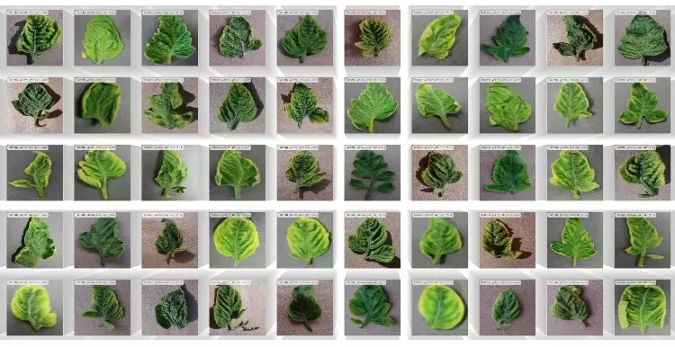

*Figure 1: Plant crop species*

Our project, the "Plant Disease Classification System," is a response to the critical need for accurate and rapid diagnosis of plant diseases. Leveraging Convolutional Neural Networks (CNN), we aim to develop a system that can classify diseases in 38 plant categories. This system will be accessible via web and mobile applications, offering a user-friendly solution for farmers and agricultural enthusiasts. (Savary, 2019) The

project's significance lies in its potential to bolster food security and sustainable agriculture by empowering early disease detection and management.

## Problem statement

Plant diseases are responsible for global crop yield losses of up to 40%, impacting food security and causing economic losses worth billions of dollars [FAO, 2019]. With the world population expected to reach 9.7 billion by 2050 [United Nations, 2019], the demand for food production is growing. Climate change further complicates matters, as it affects disease epidemiology [Savary et al., 2019]. Traditional disease detection methods are often slow and inaccurate. This underscores the urgent need for an advanced system, such as the "Plant Disease Classification System," to address these challenges.

## Project as a Solution:

The "Plant Disease Classification System" offers a modern solution to the pervasive issue of plant diseases in agriculture. Traditional methods of disease detection are often time- consuming and subjective, leading to substantial crop losses. To address this challenge, our project harnesses the capabilities of Convolutional Neural Networks (CNNs), which have proven effective in image classification tasks [Krizhevsky et al., 2012].

The CNN architecture is designed with a convolutional layer, consisting of 32 filters using 3x3 kernels and applying the Rectified Linear Unit (ReLU) activation function. Batch normalization is incorporated to normalize the activations, and dropout with a rate of 0.25 is implemented to prevent overfitting. Additionally, max pooling is used to reduce the spatial dimensions of the feature maps.

Two sets of (CONV => RELU) * 2 => POOL blocks are created to extract high-level features from the input images. Furthermore, a Fully Connected (FC) layer with ReLU activation is included for classification.

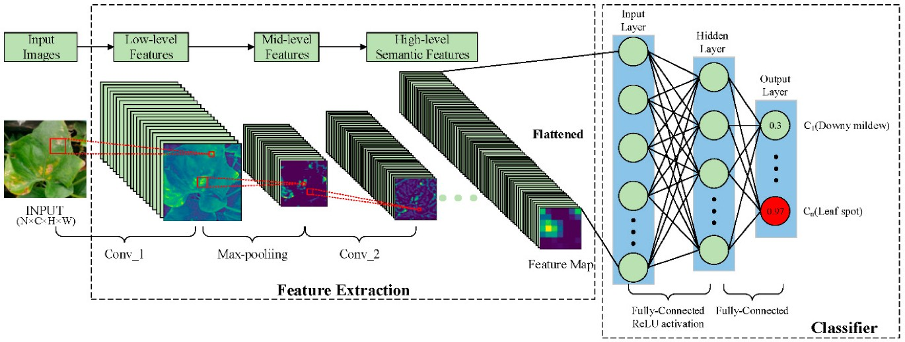

*Figure 2: Convolutional neural networks for leaf disease classification*

1. Web Application (Django-based): Users can conveniently upload images of diseased plants via a web application. The integrated CNN model will promptly analyze these images, providing accurate disease diagnoses. This tool benefits farmers and agricultural experts, enhancing disease identification speed and precision.
2. Mobile Application (Flutter-based): For on-the-go access, a mobile application developed with Flutter allows users to capture and upload images directly from their smartphones. This feature is particularly valuable for farmers in the field.

The "Plant Disease Classification System" not only offers a technical solution but also addresses the global food security challenge. By facilitating early disease detection, it minimizes crop losses and supports sustainable agriculture practices. This project bridges the gap between advanced machine learning and practical agricultural needs [Savary et al., 2019], contributing significantly to global food security and crop management.

# Aims and Objectives

## Aims

**Bridge the Gap Between Technology and Agriculture:** The primary aim of this project is to create a robust Plant Disease Classification model based on Convolutional Neural Networks (CNNs) that can accurately and swiftly identify plant diseases across a wide range of plant categories.

## Objective

1. **Develop a CNN-Based Model:** Build and train a CNN-based model using a diverse dataset encompassing 38 plant categories for effective disease classification.
2. **Create a Web Application:** Develop a user-friendly web application using the Django framework, allowing users to upload plant images for instant disease diagnosis.
3. **Design a Mobile Application:** Build a mobile application using Flutter, enabling users to capture and upload plant images via smartphones for on-the-go disease diagnosis.
4. **Integrate Comprehensive Plant Disease Database:** Incorporate a comprehensive plant disease database to support the classification model and provide users with a reference for different plant diseases.
5. **Conduct Rigorous Testing and Validation:** Thoroughly test and validate the CNN model to ensure high accuracy in disease classification.
6. **Ensure User Accessibility:** Prioritize user-friendliness in both the web and mobile applications to cater to users with varying levels of technological proficiency.
7. **Provide Open-Source Resources:** Make the disease classification model and associated tools open-source, contributing to the research and agricultural communities.

# Expected Outcomes and deliverables.

Upon the completion of this project, we anticipate the development of a user-friendly mobile application designed to empower farmers and agricultural enthusiasts in efficiently detecting plant diseases. This app, a pivotal outcome of our project, will be a valuable tool equipped with various features to assist users in maintaining the health of their crops. Users will be able to capture and upload images of their plants, and the app will swiftly provide accurate disease diagnoses. (Sladojevic, 2019) Additionally, the app will integrate a comprehensive plant disease database, enhancing its diagnostic capabilities. Users will also have the convenience of remote access via a user-friendly website interface. To ensure users make the most of its features, comprehensive guides and resources will be made available. In essence, this mobile application will be an invaluable tool for farmers, promoting informed decision-making and enhancing crop management practices.

**Features of the App:**

**Image-Based Disease Detection:** Users can capture and upload images of plants, and the app will provide rapid and accurate disease diagnoses.

**Comprehensive Plant Database:** The app will be integrated with an extensive plant disease database, enhancing its diagnostic capabilities.

**Remote Access:** Users can access the app remotely through a user-friendly website interface.

**Mobile App:** Users can detect the Plant Disease through the mobile app.

**WebApp:** Users can upload the image through the webapp and get the Realtime results instantly.

**Support and Guides:** Comprehensive guides and resources will be available to help users make the most of the app's features.

# Project risks, threats and contingency plans

## Risk and Threats

The successful execution of the "Plant Disease Classification System" project is contingent upon managing several potential risks and threats that may impact its progress and outcomes. It is imperative to identify and mitigate these challenges to ensure the project's success. The key risks and threats include:

* + 1. Data Quality and Quantity:

**Risk:** Incomplete or low-quality data in the training dataset can compromise the accuracy of the CNN model, leading to misclassifications.

* + 1. Technical Challenges:

**Risk:** Technical issues, such as model instability or software bugs, may impede the development and functionality of the classification system.

* + 1. Integration Complexity:

**Risk:** Integrating the disease database, sensor data, and multiple applications can be complex and may lead to compatibility issues.

* + 1. User Adoption:

**Risk:** User adoption of the system may be slow if it is not user-friendly or if users lack the necessary technology proficiency.

* + 1. Security and Data Privacy:

**Risk:** Ensuring the security and privacy of user data is crucial, as the system will collect and store sensitive information.

* + 1. Resource Constraints:

**Risk:** Time, and resource constraints can impact the project's ability to deliver all intended features.

* + 1. User Support and Maintenance:

**Risk:** Inadequate user support and post-deployment maintenance can affect user satisfaction and system sustainability

## Contingency Plans:

To address the identified project risks and threats, the "Plant Disease Classification System" project will implement the following contingency plans:

### Data Quality and Quantity:

Contingency: If data quality issues arise, we will prioritize data cleaning and augmentation efforts to enhance dataset quality and diversity.

### Technical Challenges:

Contingency: In the event of technical issues, we will allocate additional time for debugging, testing, and refinement to ensure system stability.

### Integration Complexity:

Contingency: To manage integration complexities, we will employ a dedicated integration team and conduct rigorous testing to address compatibility issues.

### User Adoption:

Contingency: Should user adoption be slow, we will focus on user training and provide additional support resources to enhance user-friendliness.

### Security and Data Privacy:

Contingency: To address security and data privacy concerns, we will implement enhanced security measures, conduct regular security audits, and ensure compliance with data protection regulations.

### Resource Constraints:

Contingency: In the face of resource constraints, we will regularly reassess the project scope and timeline, making adjustments as necessary to meet project objectives.

### User Support and Maintenance:

Contingency: To ensure effective user support and maintenance, we will establish a dedicated support team and plan for ongoing post-deployment support and system updates.

# Methodology

The "Plant Disease Classification System" project follows a prototype methodology, emphasizing the iterative development of prototypes to achieve the expected outcome. This approach allows for the refinement of the system based on continuous user feedback and evolving requirements.

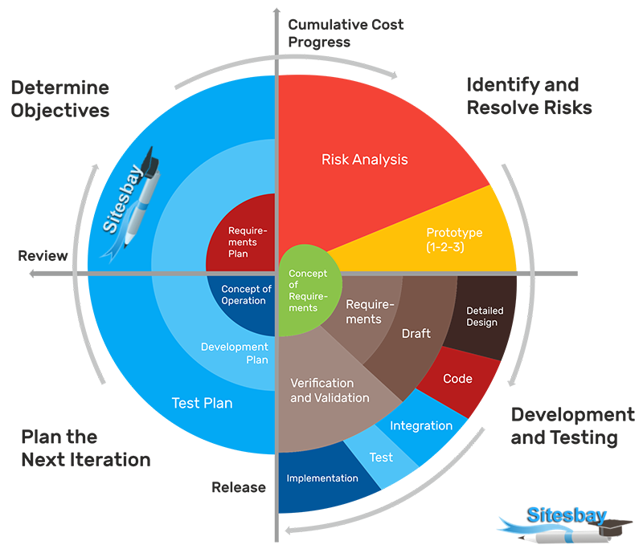

*Figure 3: Prototype Methodology 1*

## Prototype methodology

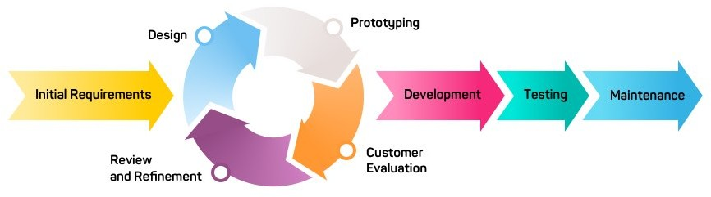

*Figure 4: Prototype Methodology 2*

**Prototype Development:** Create an initial prototype, including a basic CNN-based model and simplified web and mobile interfaces.

**User Feedback and Iteration:** Gather user feedback to refine the system in iterative cycles, addressing evolving requirements.

**Progressive Enhancement:** Enhance the system with each prototype iteration, improving the classification model and user interfaces.

**Testing and Validation:** Rigorously test and validate the system throughout each prototype phase to ensure accuracy and reliability.

**Deployment of Improved Prototypes:** Deploy improved prototypes in iterative cycles, providing users with a more refined and feature-rich system.

**Ongoing User Engagement:** Maintain ongoing user engagement to gather feedback and align the project closely with user requirements and expectations.

# Resource Requirement

For the successful completion of this project, required tools and technologies are as follows:

## Hardware Requirement:

1. Laptop/Desktop
2. CPU: Intel/amd/apple ≈ 10th Gen intel
3. GUP: NVIDIA CUDAs
4. SSD: NVME
5. RAM: 8GB RAM

## Software Requirement

1. Operating System: Windows or Mac
2. Stable Internet Connection
3. IDE: VS Code
4. Programming Language: Python, JavaScript, HTML, CSS, Dart
5. Framework: Django, Anaconda, Google Collab, HTML, CSS JavaScript, Bootstrap, Flutter
6. Database: MySQL/GraphQL
7. Designing and Prototyping: Adobe XD, Adobe illustrator, Figma, Canva
8. Version Control: GitHub
9. Microsoft Visio or Draw.io (for software development flowchart)
10. Gantt project (To make activity timeline)
11. Datasets : Kaggle/Plant Village(site)

# Work Breakdwown Structure

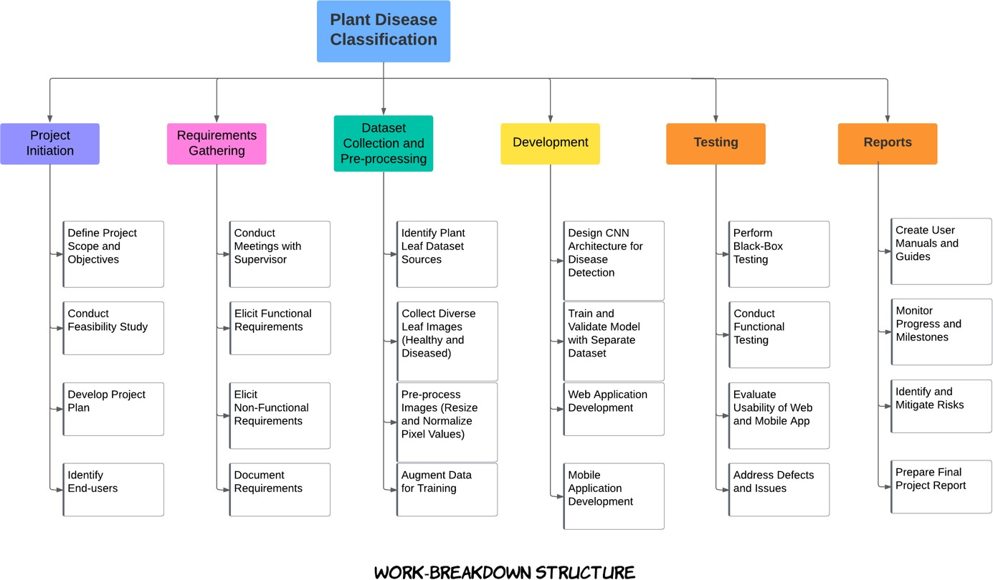

*Figure 5: Work Breakdwown Structure*

# Milestones chart

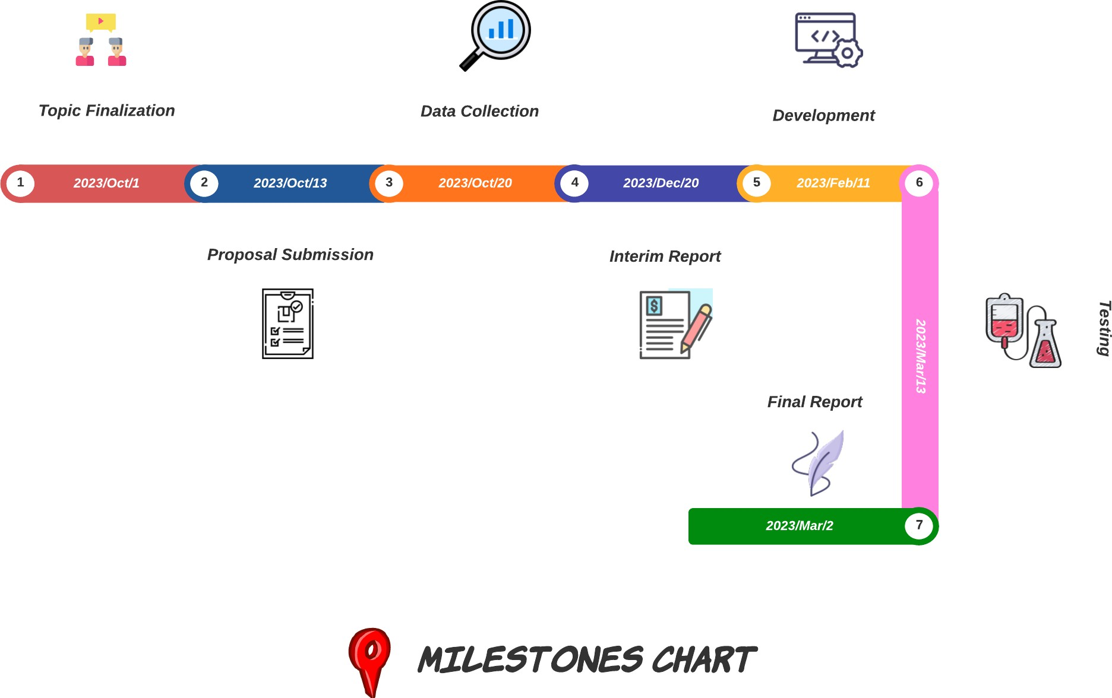

*Figure 6: Milestones chart*

# Project Gantt chart

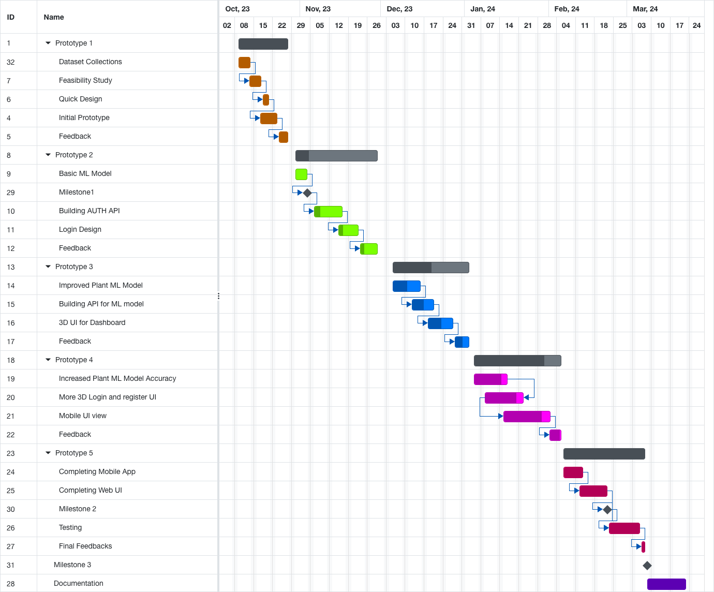

*Figure 7: Project Gantt chart*

A Gantt chart is a chronological illustration of a completed or upcoming work. The time and duration of the procedures are shown. The representation is horizontal. The Gantt

chart above categorises work breakdown structure by time. As mentioned in the milestone section above, there are several milestones established over the length. Project completion takes about 6 months from start to finish. The timetable spans from subject selection through project submission.

# Conclusion:

The "Plant Disease Classification System" project represents a pivotal advancement in agricultural technology, offering a visionary solution to the challenges faced by farmers and agricultural experts in managing plant diseases. With its high-accuracy disease classification model, user-friendly web and mobile applications, comprehensive disease databases, and open-source resources, the project is poised to revolutionize plant disease diagnosis. By embracing a prototype methodology and iterative development, user feedback continuously guides system enhancement. The project's mission is to enhance food security, minimize crop losses, and promote sustainable agriculture, cementing its role as a valuable resource for the agricultural community.Along this project I get to learn about various Modern programming architecture, Apis and various frameworks that helps me to get a job in some industry leading company.

# Bibliography

Krizhevsky, A., Sutskever, I., & Hinton, G. E. (2012). "ImageNet Classification with Deep Convolutional Neural Networks*." Advances in Neural Information Processing Systems. Retrieved from arXiv.*

Savary, S., et al. (2019). "The global burden of pathogens and pests on major food crops." *Nature Ecology & Evolution*, 3(3), 430-439.

Food and Agriculture Organization of the United Nations (FAO). (2019). "The State of Food and Agriculture 2019. Moving forward on food loss and waste reduction." Retrieved from FAO Website.

United Nations. (2019). "World Population Prospects 2019." Retrieved from United Nations Website.

Madden, L. V., Hughes, G., & van den Bosch, F. (2007). *The Study of Plant Disease Epidemics. American Phytopathological Society.*

Agrios, G. N. (2005). *Plant Pathology* (5th ed.). Academic Press.

Hsiang, T. (2018). *Deep Learning for Image-Based Plant Disease Detection*. CRC Press.

Singh, A., & Ganapathysubramanian, B. (2017). *"A Robust Deep-Learning-Based Detector for Real-Time Tomato Plant Diseases."* Computers and Electronics in Agriculture, 138, 200-209.

Sladojevic, S., Arsenovic, M., & Anderla, A. (2016). *"Deep Neural Networks Based Recognition of Plant Diseases by Leaf Image Classification."* Computers in Industry, 87, 12-20.

Mahlein, A.-K. (2016). *"Plant Disease Detection by Imaging Sensors – Parallels and Specific Demands for Precision Agriculture and Plant Phenotyping."* Plant Disease, 100(2), 241-251.

# Appendix

## Similar Projects:

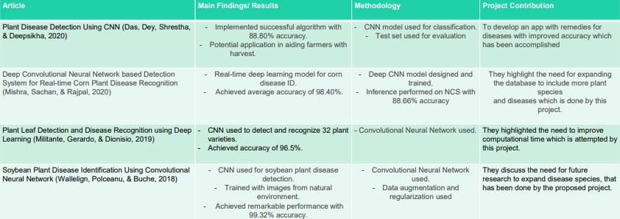

*Figure 8: Similar Projects:*

## Use Case Diagram

*Figure 9: Use Case Diagram*

A use case diagram for plant disease detection using CNN (Convolutional Neural Network) illustrates the main interactions between the system's actors (users and administrators) and the system itself. It provides a high-level view of the primary usage scenarios and functionalities of the plant disease detection application. Below is a description of the key elements in the use case diagram:

**Actors:**

User: Represents the end-users of the plant disease detection system, such as farmers, agronomists, or gardeners. They interact with the system to upload plant images and receive disease detection results.

**Use Cases:**

**Upload Image:** This use case represents the user's ability to upload plant images into the system for disease detection. Upon uploading the image, the system processes it using the CNN model and provides the user with the disease classification results.

**View Results:** After the image is processed, the user can view the disease detection results, which show the detected disease and any relevant information about its severity or treatment recommendations.

## System Flow chart

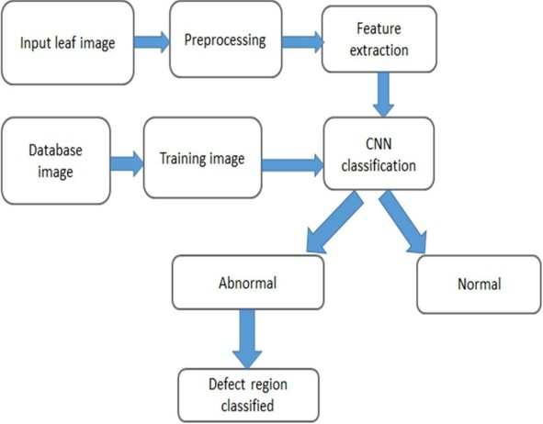

*Figure 10: System Flow chart*

To achieve accurate detection, a substantial dataset is necessary. Thus, the dataset is augmented with additional images to enhance its diversity. The database used for training contains over 5000 images, while a separate set of around 1000 images is used for validation.

The process of obtaining and labelling images is explained in the paper. Multiple samples of images are collected in various formats and resolutions, introducing variations in quality. Pre-processing is employed to achieve consistent feature extraction. Images with resolutions smaller than 500px are excluded from the dataset, ensuring that higher resolution images, containing essential information for feature learning, are used. The images are resized to 50x50 to reduce training time using the OpenCV framework in Python.

The pre-processing of images involves removing background noise, normalizing intensity levels, eliminating reflections, and masking image sections. The dataset consists of images of plant leaves, different diseases, pests, and soil, which are trained and classified into various clusters with respective labels.

The use of Convolution Neural Networks enables accurate analysis for leaf disease detection. The paper employs unsupervised learning classification, as the input images are unknown and new to the algorithm. In real-time applications where inputs are unfamiliar, unsupervised learning is commonly used.

The machine learning algorithm, based on feature extraction parameters, predicts whether crops are likely to experience pest and disease attacks in the future. The detection process involves the main steps as shown in Figure 4, indicating the flow and sequence of operations.



*Figure 11: Convolutional neural networks for leaf disease classification*